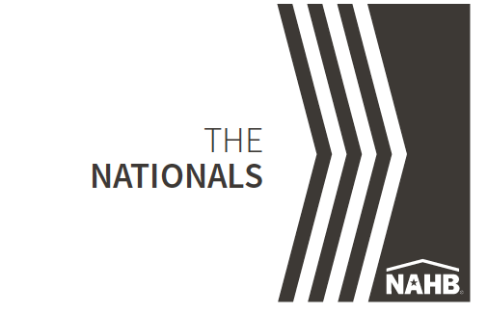

NAHB Announces The Nationals Silver Award Winners

NAHB’s [National Sales and Marketing Council](https://www.nahb.org/nahb-community/councils/national-sales-and-marketing-council)(NSMC) has announced the 2024 [THE NATIONALS SILVER AWARDS](https://online.flippingbook.com/view/118604117/).

(Company name) received Silver Award honors for (category name).

(Paragraph 3 - briefly describe category and winner)

The Nationals

Showcasing the most exciting trends in New Homes Sales and Marketing along with 55+ Housing throughout North America, The Nationals honor the best in the building industry — including home builders, developers, associates, and consultants — for their determination, integrity, creativity, and endurance. A diverse panel of industry professionals selected the Silver Awards winners from over 1,200 entries.

Silver Award winners are the top vote recipients in each category and are the finalists for The Nationals Gold Awards.

NAHB Global Innovation Categories recognize the most cutting-edge, advanced and original products, services, homes, communities and champions of the building industry from around the world.

The Nationals will be presented Feb. 25, 2025, in Las Vegas during the International Builders Show.

“The Nationals’ award winners set the standard for excellence in new home sales, marketing and design,” said Tiffany George, chairperson of The Nationals. “These prestigious awards have represented NAHB’s dedication to recognizing innovation, creativity and success for more than 40 years.”

Started in 1982 as the Institute of Residential Marketing, The Nationals award program recognizes superior new home sales and marketing achievements.

The awards honor excellence in product and community design, advertising, marketing and sales by individuals and teams across 61 categories spanning various disciplines of the new home industry.

During a four-day judging process, a panel of 13 industry professionals from across the country determined the Silver and Gold Award Winners from a field of more than 1,200 entries.

To view Silver Award Winners and order tickets to the awards ceremony, visit

For more information, email [Lisa Parrish](mailto:lparrish@thenationals.com?subject=Information%20-%20The%20Nationals), or call 800-658-2751 or 909-987-2758.

**• #NAHBawards • #TheNationalsAwards • #winningmySam**

The [National Association of Homebuilders](https://www.nahb.org/nahb-community/awards) honors members on multiple levels for their remarkable contributions to the housing industry.  
[For more information – NAHB Awards](https://www.nahb.org/nahb-community/awards)