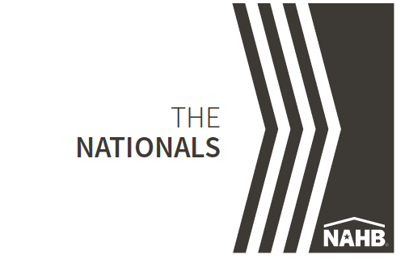
Silver Award Winners Announced for National Sales and Marketing Awards

NAHB’s National Sales and Marketing Council (NSMC) has announced Silver Award Winners for The Nationals new home sales and marketing awards.

(Company name) received Silver Award honors for (category name).
(Paragraph 3 - briefly describe category and winner)
The Nationals salutes and honors the best in the building industry — including home builders, developers, associates and consultants — for their determination, integrity, creativity and endurance.

Silver Award Winners are the top vote recipients in each category and are the finalists for the Gold Award. Gold Awards in each category will be presented in February 2022 in Orlando, FL.

"The Nationals are the most prestigious awards of their kind, setting the benchmark for innovations in new home design, marketing and sales," said John Madden, chairperson of the Nationals. "NAHB's commitment to recognizing originality, imagination and success has been exemplified by its award winners since the competition's inception."

Started in 1982 as the Institute of Residential Marketing, The Nationals award program continues to recognize superior new home sales and marketing achievements.
With 61 categories across various disciplines of the new home industry, the awards honor excellence in product and community design, advertising, marketing and sales achievements by individuals and sales teams.

During a Four-day judging process, a panel of 13 industry professionals from across the country determined the Silver and Gold award winners from a field of over 1200
entries.

The Nationals are co-sponsored by Wells Fargo Home Mortgage.

To view sliver award winners or to order tickets to the event, visit http://www.thenationals.com

For more information, e-mail Lisa Parrish, or call at 800-658-2751 or 909-987-2758.

